## **Submitting Referrals into CAS Housing Programs via HMIS**

**Process Flow**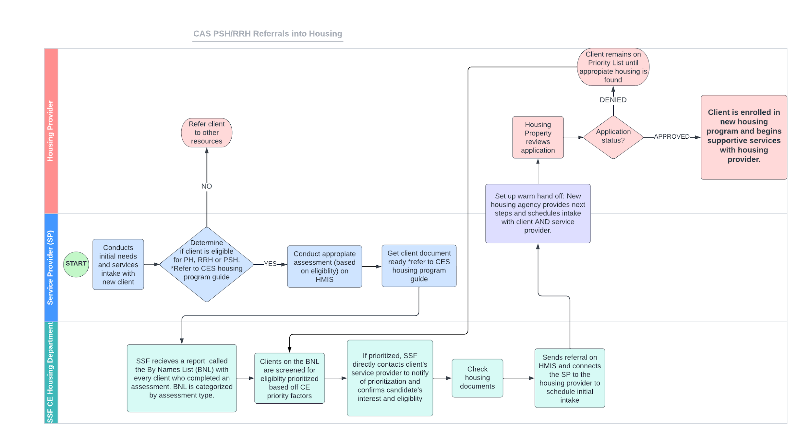

## **Checking Opening Availability**

Looker Report:

1. Prior to submitting a referral, check the Housing Program availability by switching to the housing program’s primary agency. Example 



1. Click the Referrals tab and select ‘Availability’



1. Select ‘CES Community Queue CA-503’

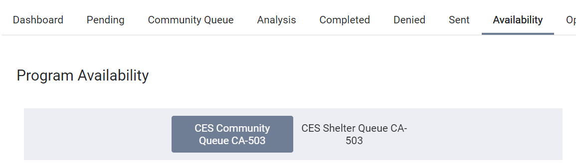

1. Select ‘Limited Availability’ to see if there are available openings



*Openings will look like this:*

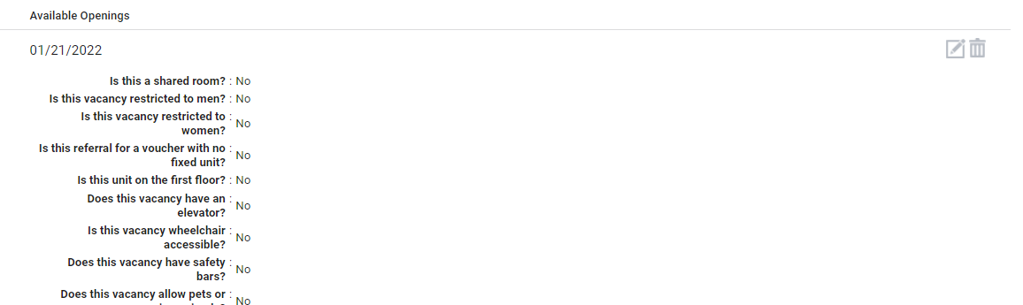

1. An opening indicates that an appointment can be scheduled (1 opening = 1 unit/ program spot available)
   1. Check the opening notes to see unit information and description(1 bedroom, ADA unit, first floor unit, etc)
2. If there are openings that are outdated (beyond 90 days, email the housing provider to see if the opening is still available).

**HMIS Steps**

**Send Housing Referral**

1. Switch to the housing agency that will be receiving the referral by selecting the agency on the upper right corner.

1. Send housing referral:
   1. Search up the client’s record by using their HMIS UID or first and last name (check birthdate if there are duplicate names)
   2. Under the client’s record, navigate to the ‘Assessment’ tab
   3. Select the most recently completed assessment – and click on ‘Eligibility’
   4. Refer client “directly to the CES CommunityQueue” (if the message “Client pending on Community Queue - CES Community Queue” is showing, go to next section ‘Alternate Referral Process’)
   5. Click ‘Send Referral’ - Providing notes is optional
   6. Under the ‘Reassign’ section, select the housing program opening in the program bar
      * Check the Program opening notes for specific unit information to ensure you are referring to the correct opening.
   7. After selecting the program an “Opening” bar should appear
   8. Select the appropriate opening from the list (work from the oldest opening to newest if openings are all the same)
   9. Click ‘Save Changes;
   10. Once completed, the referral will appear in the client’s history.
   11. The referral will appear as “Pending,” until the housing provider either updates it to:
       * “In Progress”- to indicate that they have seen the referral and are still working on it OR
       * “[Insert Date] to indicate they have accepted the referral and enrolled the client into the program
       * It is important that the housing provider maintains accurate record of the client’s referral status. Gentle reminders may be given to housing providers who fail to do so.

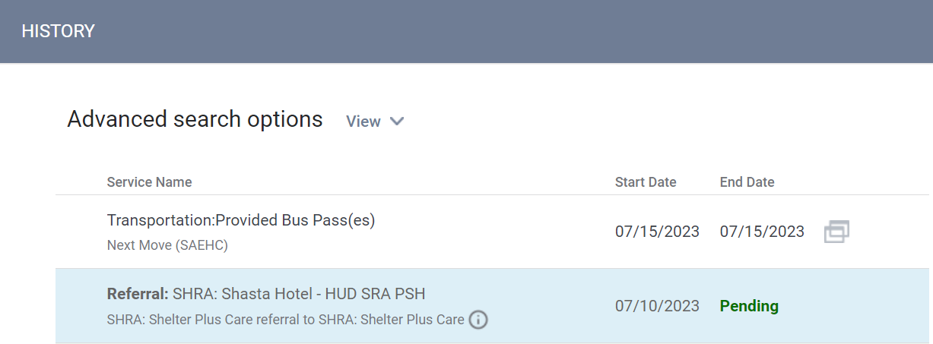

**Alternate Referral Process (for clients currently pending in the Community Queue but not referred to housing program)**

1. If the client is already on the CES Community Queue go back to the HMIS home screen and navigate to the ‘Referrals’ tab



1. From here, click on the Community Queue tab
2. Select ‘CES Community Queue CA-503’



1. Input the client’s UID in the search bar and click search
2. Hover over the client until the edit icon (box with a pencil) appears to the left of the client’s name
3. Click on the edit button
4. On this screen, scroll down to the ‘Reassign’ section and select the housing program in the program bar

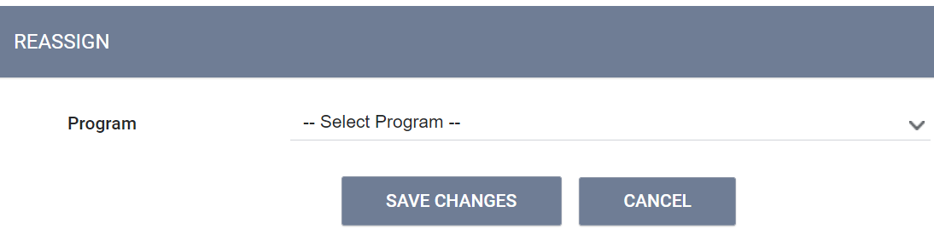

1. Select the appropriate opening from the list (work from the oldest opening to newest)
2. Click save changes
3. Once completed, the referral will automatically close out the bed vacancy

**If housing providers have any HMIS questions on how to accept, reject, enroll referrals, please send them this document:**

[**https://docs.google.com/document/d/1XRSO-Wft7DfrxFvJtKtSamF890D7Sa_rrr0iqdFGxD8/edit?usp=sharing**](https://docs.google.com/document/d/1XRSO-Wft7DfrxFvJtKtSamF890D7Sa_rrr0iqdFGxD8/edit?usp=sharing)